FUTURE BUSINESS ANALYST SEASON 6
ROUND 2 BUSINESS ANALYTICS REPORT
From accounts to assets
Turning DNSE's unfunded accounts into regular investors

Selected organisation | DNSE Securities Joint Stock Company (HOSE: DSE)
Category | Wealthtech and technology-enabled financial institution
Prepared for | The senior management team of DNSE
Team | KTQT FTUers
Main-body length | 3,487 words (Sections 1 to 5, including tables and captions)
Date | 27 September 2026

Executive summary
DNSE Securities leads Vietnam's brokers in account growth. Zero-fee trading on the Entrade X app, together with Margin Deal, Future X and the Ensa assistant, brought it one in five of the country's new securities accounts in 2025 and more than 1.7 million accounts by mid-2026, 12.3 per cent of the market. Customer money has not grown with the account base. DNSE holds 2.3 per cent of the cash investors keep at brokers, 1.4 per cent of margin lending and 0.6 per cent of industry profit. In December 2025, 5.7 per cent of its accounts used at least one product and 1.8 per cent held net assets of VND 10 million or more.
The funding gap is costly. Brokerage revenue has been below its direct cost for 16 consecutive quarters, and in the first half of 2026 each extra VND 100 of revenue came with VND 115 of extra cost. Without a parent bank, DNSE borrows short term against pledged deposits that tie up 38 per cent of its assets, against 4 to 9 per cent at four large peers. Platform and overhead costs rose 12.5 times between 2021 and 2025 and fall on few funded customers, about VND 7.3 million a year for each account with VND 10 million or more.
The evidence points to three causes, supported to different degrees. DNSE's tools attract young traders with little capital, while wealthier savers appear to prefer bank-affiliated or advisory brokers. Complaints about deception, sign-up bonus terms and a closure fee appear in 37 per cent of DNSE's negative reviews since 2025, against 8 per cent at VPS. No DNSE product turns a salaried customer's intention to invest into regular deposits, and its two saving products had 12,100 registered users and 1,037 active users at the end of 2025.
We prioritise the funding gap among existing accounts. It scores highest on scale, with about 1.4 million unfunded accounts, and on cost of fixing, because DNSE has already paid for the accounts and the infrastructure. Trust ranks level with it under equal weights, so trust becomes a design condition of the solution. We recommend Payday Portfolio, an automatic, goal-based investing plan for salaried customers who intend to invest but keep postponing. A standing order that the customer controls moves a chosen amount on payday into DNSE's idle-cash account, Tài khoản không ngủ ("never-sleeping account"), and then into Trứng Vàng ("golden egg") bonds, funds or exchange-traded funds. Customers can pause or cancel in one tap, withdraw at any time and close the account free of charge.
In the base case, 150,000 savers contributing VND 1.5 million a month would hold VND 2.8 trillion after 18 months, 1.4 times DNSE's current investor cash. Customer segments and intent remain hypotheses because DNSE does not publish customer-level data. Round 3 should test them in a randomised pilot with 20,000 dormant customers. The headline KPI is the number of accounts holding VND 10 million or more, 27,100 at the end of 2025 (1.8 per cent), with a target of 85,000 within 18 months, 5 per cent of the mid-2026 account base.

Table of contents
Executive summary 2
1. Introduction 5
1.1 DNSE and its business model 5
1.2 Vietnam context and the market gap 5
1.3 Business question and scope 6
2. Findings of observations 7
2.1 Evidence base, data preparation and method 7
2.2 Finding 1. Accounts are opened but rarely funded 7
2.3 Finding 2. Revenue grows, but costs grow faster 8
2.4 Finding 3. Borrowing without a parent bank ties up the balance sheet 8
2.5 Finding 4. Idle accounts turn the platform into a fixed cost 9
2.6 Finding 5. Trust complaints are specific to DNSE 10
2.7 Finding 6. Saving products exist but reach few customers 10
3. Discussion and main analysis 12
3.1 From symptom to root cause 12
3.2 Target segments 12
3.3 Problem prioritisation 13
3.4 Strategic alternatives and trade-offs 14
4. Recommendations 15
4.1 Payday Portfolio 15
4.2 Value logic and scenarios 15
4.3 Validation direction 16
5. Conclusion 17
Appendices 18
Appendix A. Data preparation and quality 18
Appendix B. DNSE financial data 20
Appendix C. Market and peer data 23
Appendix D. Customer review analysis 24
Appendix E. Findex segment analysis 26
Appendix F. Assumptions, sensitivity and alternative explanations 27
References 30

List of figures and tables
Figures
Figure 1. Returns on a saver's idle cash, September 2026 5
Figure 2. Investor cash held at brokers, third quarter of 2025 = 100 6
Figure 3. Activity, balances and product use among DNSE accounts, December 2025 7
Figure 4. DNSE's share of eight markets, 2025 to mid-2026 8
Figure 5. Brokerage revenue against direct brokerage cost, by quarter 8
Figure 6. Funding structure of DNSE and four peers, second quarter of 2026 9
Figure 7. Platform and overhead cost proxy and the accounts that carry it 9
Figure 8. Complaint themes in negative Google Play reviews 10
Figure 9. Vietnamese adult segments by digital habit and formally held surplus 11
Figure 10. Root-cause tree for unfunded accounts 12
Figure 11. How Payday Portfolio works 15
Figure 12. Validation roadmap for Round 3 17
Tables
Table 1. Customer segments and objectives 13
Table 2. Candidate problems scored from 1 (weak) to 5 (strong) 13
Table 3. Strategic alternatives scored from 1 (weak) to 5 (strong) 14
Table 4. Outcomes 18 months after launch (all inputs are assumptions) 16
Table 5. Priority assumptions, tests and thresholds for Round 3 16

1. Introduction

1.1 DNSE and its business model
DNSE Securities began in 2007 as Dai Nam Securities. The Encapital group took control in late 2020, rebuilt it as a technology-led broker without branches and listed it on HOSE in July 2024 (CafeF, 2024). Its Entrade X app offers free share trading for life, derivatives, deal-by-deal margin loans (Margin Deal) and an artificial intelligence assistant (Ensa). Two products hold customer money. Tài khoản không ngủ ("never-sleeping account"), an idle-cash account launched in June 2025, pays 1.8 to 4.3 per cent a year, and Trứng Vàng ("golden egg") sells bonds from VND 1 million (DNSE Securities, 2026b, 2026c). Because share trading is free, DNSE earns mainly on balances. In the first half of 2026, margin interest supplied 40 per cent of operating revenue, interest on its own deposits and bonds 23 per cent, brokerage 26 per cent and proprietary trading 9 per cent (Table B1).

1.2 Vietnam context and the market gap
With zero commissions now common, Vietnamese brokers earn their profit from lending, which brought in VND 12.2 trillion in the second quarter of 2026 against VND 3.7 trillion from brokerage (Vietstock, 2026d). Four conditions change how DNSE's data are read.
First, savers are paid more to keep money in banks. Credit grew 19.0 per cent in 2025 against deposit growth of 11.4 per cent (FiinRatings, 2026), and 12-month deposit rates rose about 2.5 points in 2026, to 6.8 per cent at state banks (VnEconomy, 2026; VietnamNet, 2026). A typical DNSE customer earns 2.1 to 2.3 per cent on idle cash, below inflation of 4.45 per cent (Figure 1).
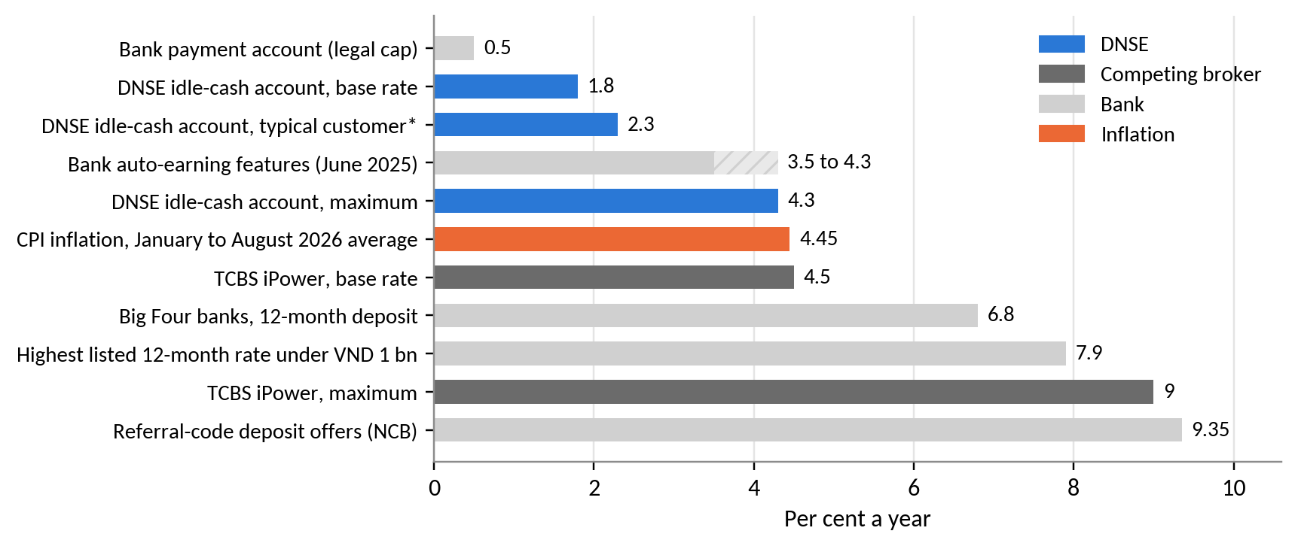
Figure 1. Returns on a saver's idle cash, September 2026
Source: DNSE Securities (2025, 2026b); TCBS (2026); VietnamNet (2026); VnExpress (2026b); Báo Đấu thầu (2026). * Balances of VND 1 to 500 million.
Second, the 2026 outflow is market-wide. Investor cash at brokers fell 38 per cent in three quarters while household bank deposits reached a record VND 11 quadrillion (VnEconomy, 2026; Vietstock, 2026e). DNSE's cash fell by the same proportion (Figure 2), so its recent decline is cyclical while its small share of cash is structural.
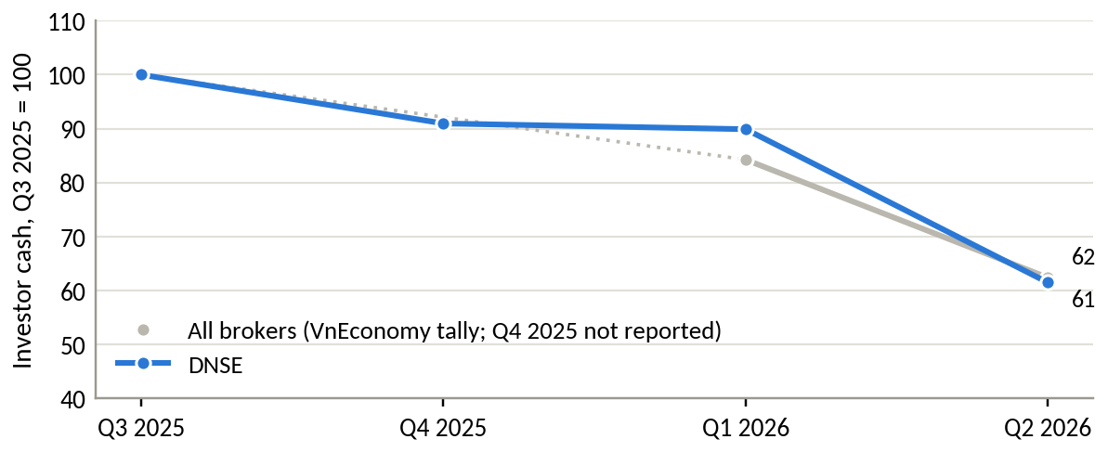
Figure 2. Investor cash held at brokers, third quarter of 2025 = 100
Source: VnEconomy (2026); DNSE filings. Industry total for Q4 2025 not reported.
Third, bank-owned brokers supplied 62 per cent of lending growth in the second quarter of 2026 (Vietstock, 2026c), so DNSE cannot win on the price of credit. Fourth, access is no longer the constraint. Internet use reaches 84 per cent of the population (Kemp, 2026), and open banking standards take effect in March 2027 (State Bank of Vietnam, 2024).
The market gap lies between banks, which hold salaries and trust but offer little investment, and brokers, whose products start only after a customer has decided to invest. Bank-affiliated brokers serve mainly their parents' customers, and zero-fee apps serve active traders (Table C3).

1.3 Business question and scope
Business question. Why do DNSE's accounts not become funded relationships, and which single initiative would convert them most cost-effectively within its capabilities and regulatory limits? It covers retail customers from account opening to regular funding, excluding investment banking and proprietary trading.

2. Findings of observations

2.1 Evidence base, data preparation and method
The evidence combines DNSE's filed statements for 2018 to mid-2026, reconciled to the reviewed half-year statements, its 2025 annual report, peer and industry data, 3,299 app reviews of DNSE, VPS and FPTS, and Global Findex 2024 data (Table A1). Reviewed filings override press figures, market shares are compared only within their own exchange, and missing observations stay missing. Spam, 23 per cent of DNSE's Google Play reviews, was removed with tested rules. The methods are share and per-account comparisons, unit costs, review themes weighted by helpful votes and segment rankings, and both scoring tables are re-run under equal and random weights (Appendix A; Table F2). These methods show associations. DNSE publishes no customer-level data, so claims about segments and intent are labelled as hypotheses, and reviews over-represent dissatisfied customers.

2.2 Finding 1. Accounts are opened but rarely funded
DNSE opened 518,514 accounts in 2025, one in five of Vietnam's new accounts, and ended the year with 1,512,920. In December 2025 only 85,739 (5.7 per cent) used any product, and 27,100 (1.8 per cent) held net assets of VND 10 million or more (Figure 3). Even if every margin loan is counted against them, the other 1.49 million accounts can hold at most VND 20.7 trillion of the VND 53.5 trillion in customer assets, so at least 61 per cent sits in fewer than 2 per cent of accounts (Appendix A).
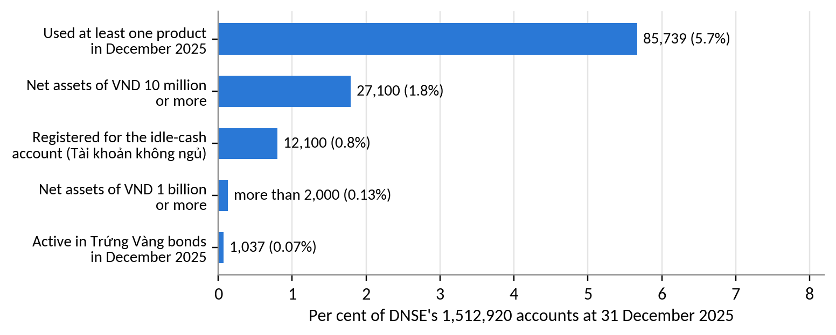
Figure 3. Activity, balances and product use among DNSE accounts, December 2025
Source: DNSE Securities (2026c).
The closer a measure sits to money, the smaller DNSE becomes (Figure 4). It holds 12.3 per cent of accounts but 2.3 per cent of investor cash, 1.4 per cent of margin lending and 0.6 per cent of industry profit. Assets per account fell 9.5 per cent in 2025 while the VN-Index rose 41 per cent (Thanh Niên, 2025). The gap is specific to DNSE. VPBankS and TCBS lend 8 and 12 times more per account, and VPS, also without a parent bank, 5 times more (Table C2).
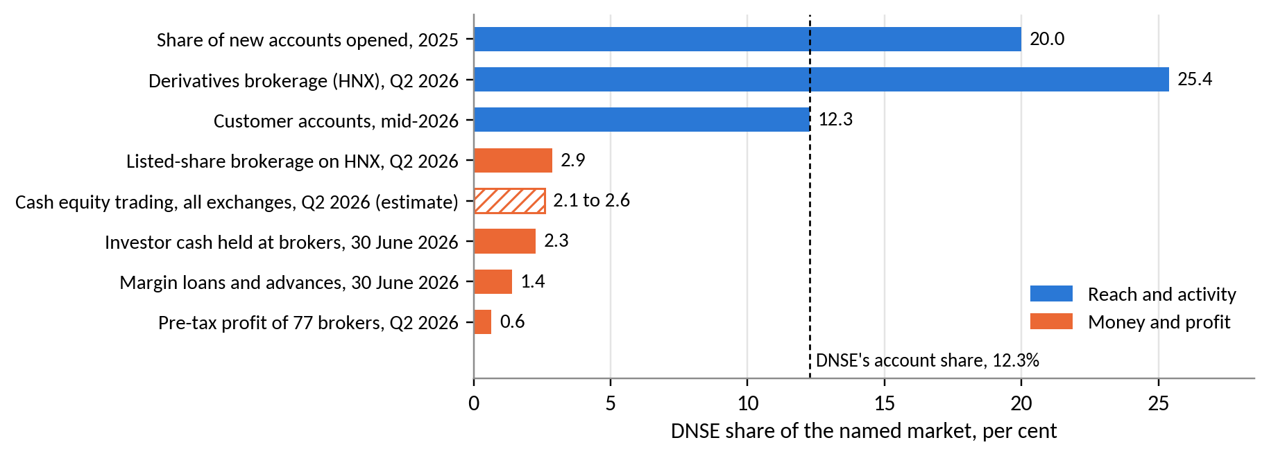
Figure 4. DNSE's share of eight markets, 2025 to mid-2026
Source: VSDC; HNX; VnEconomy (2026); Vietstock (2026c); CafeF (2026); DNSE filings. Hatched bar estimated (Table C1).
Insight. DNSE's reach is strong. Value is lost at the first deposit.

2.3 Finding 2. Revenue grows, but costs grow faster
Operating revenue rose 8.1 times between 2021 and 2025, while pre-tax profit excluding proprietary trading has stayed between VND 128 and 221 billion a year since 2022 (Table B1). Brokerage revenue has been below its direct cost for 16 consecutive quarters, a cumulative shortfall of VND 190 billion (Figure 5), partly because DNSE pays exchange fees on free trades and in 2025 also paid derivatives margin fees for customers (Vietstock, 2025). In the first half of 2026 each extra VND 100 of revenue brought VND 115 of cost, and annualised return on equity fell to 3.8 per cent, below a 12-month state bank deposit.
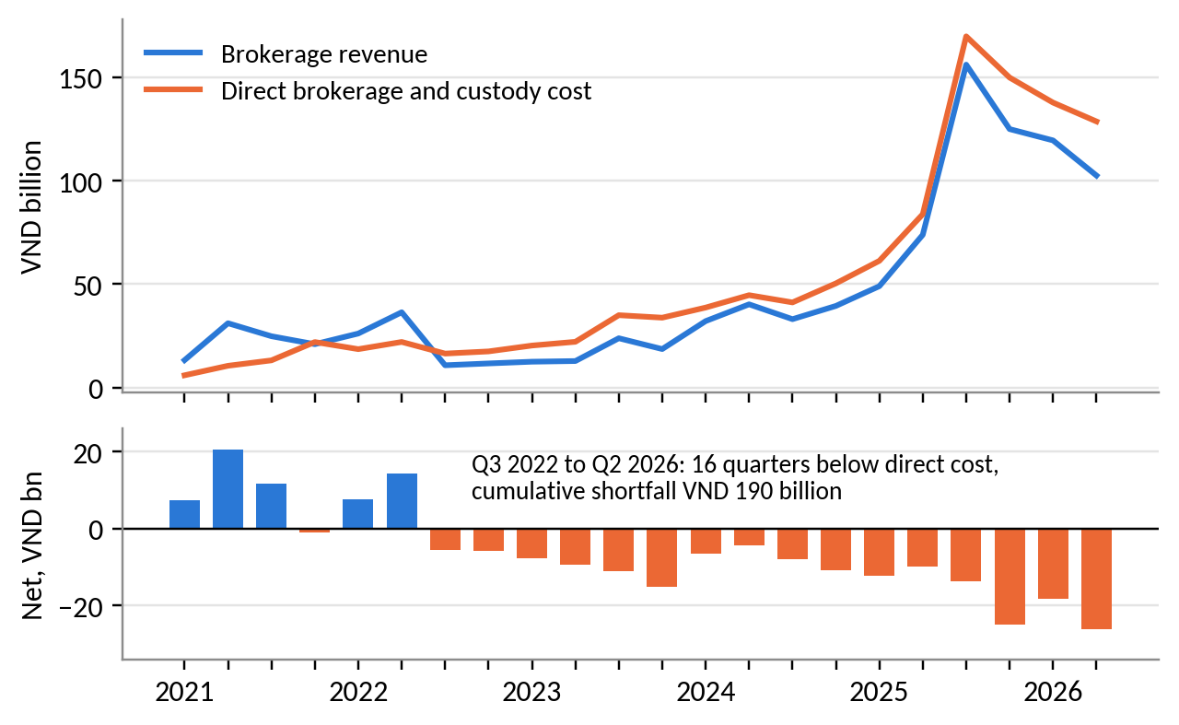
Figure 5. Brokerage revenue against direct brokerage cost, by quarter
Source: DNSE filings via Vietcap Securities (2026).
Insight. An extra free trade loses money, so profit growth has to come from balances.

2.4 Finding 3. Borrowing without a parent bank ties up the balance sheet
Lending is DNSE's only wide-margin business, yet its estimated cost of funds rose from 3.6 per cent in mid-2024 to 6.5 per cent in the second quarter of 2026, and the net interest margin fell from 5.0 per cent in 2024 to 3.5 per cent in the first half of 2026. Short-term bank loans supply 86 per cent of borrowing, secured on pledged deposits and bonds (DNSE Securities, 2026a, note 8b). These low-yield assets make up 37.6 per cent of DNSE's balance sheet, against 4 to 9 per cent at four large peers with a similar cost of funds (Figure 6). The cost of having no parent bank therefore shows up in collateral and short maturities.
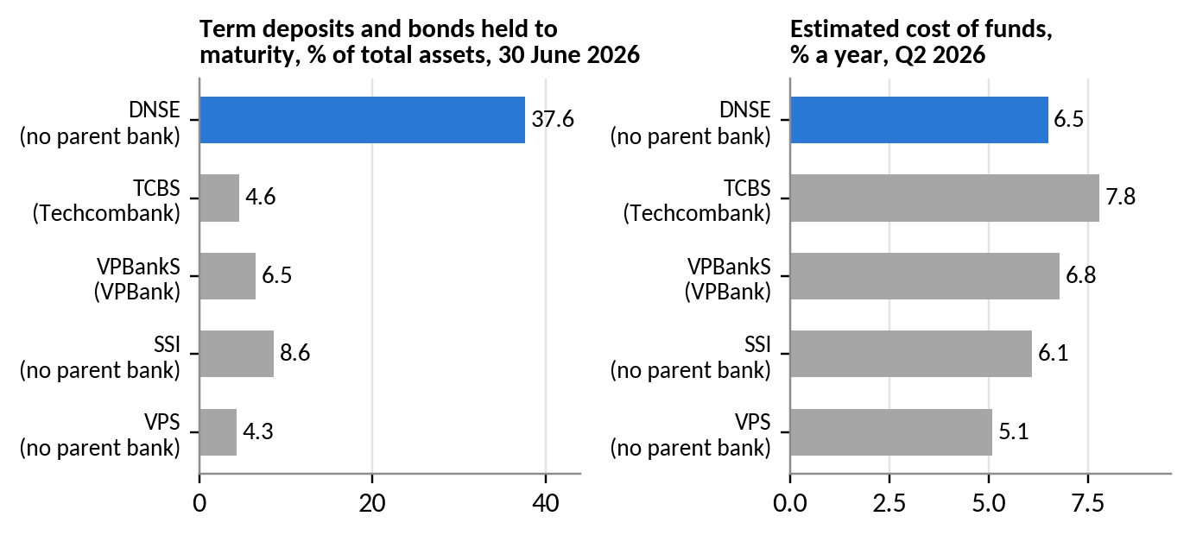
Figure 6. Funding structure of DNSE and four peers, second quarter of 2026
Source: filed statements via Vietcap Securities (2026); authors' calculations.
Insight. More margin lending needs more pledged collateral. Fee income on customer balances uses less capital.

2.5 Finding 4. Idle accounts turn the platform into a fixed cost
DNSE does not disclose technology spending. A proxy of staff costs, outsourced services, and depreciation and amortisation rose 12.5 times between 2021 and 2025, to VND 198 billion, while revenue rose 8.1 times (Table B3). The 2025 proxy equals VND 0.13 million per account but VND 7.3 million per account with VND 10 million or more (Figure 7). The proxy may include other overheads, so it shows trend and scale only.
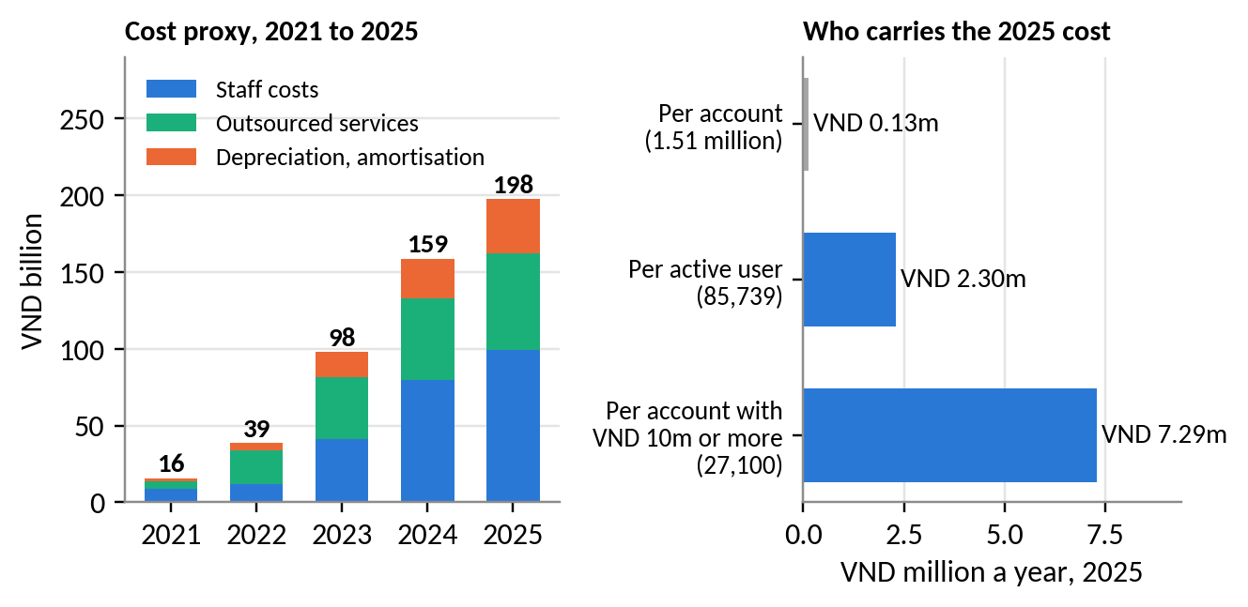
Figure 7. Platform and overhead cost proxy and the accounts that carry it
Source: DNSE filings; DNSE Securities (2026c); authors' calculations.
Insight. Fewer than 2 in 100 accounts carry the platform's cost, so activation is the cheapest way to cut unit costs.

2.6 Finding 5. Trust complaints are specific to DNSE
Among 278 negative DNSE reviews on Google Play, crashes and login failures appear in 27 per cent and identity checks in 21 per cent. Complaints about deception, sign-up bonus terms and the closure fee appear in 24 per cent but draw 43 per cent of the helpful votes (Figure 8). The most-endorsed say a VND 100,000 reward required a VND 2 million deposit and closing an account cost VND 100,000.
Reviews since 2025 separate the two problems. Reliability complaints are at least as common at VPS (46 per cent) as at DNSE (38 per cent), yet VPS lends five times more per account. Trust complaints reach 37 per cent at DNSE against 8 per cent at VPS and 1 per cent at FPTS. A fine from the State Securities Inspectorate in August 2026 adds to these doubts (Market Times, 2026).
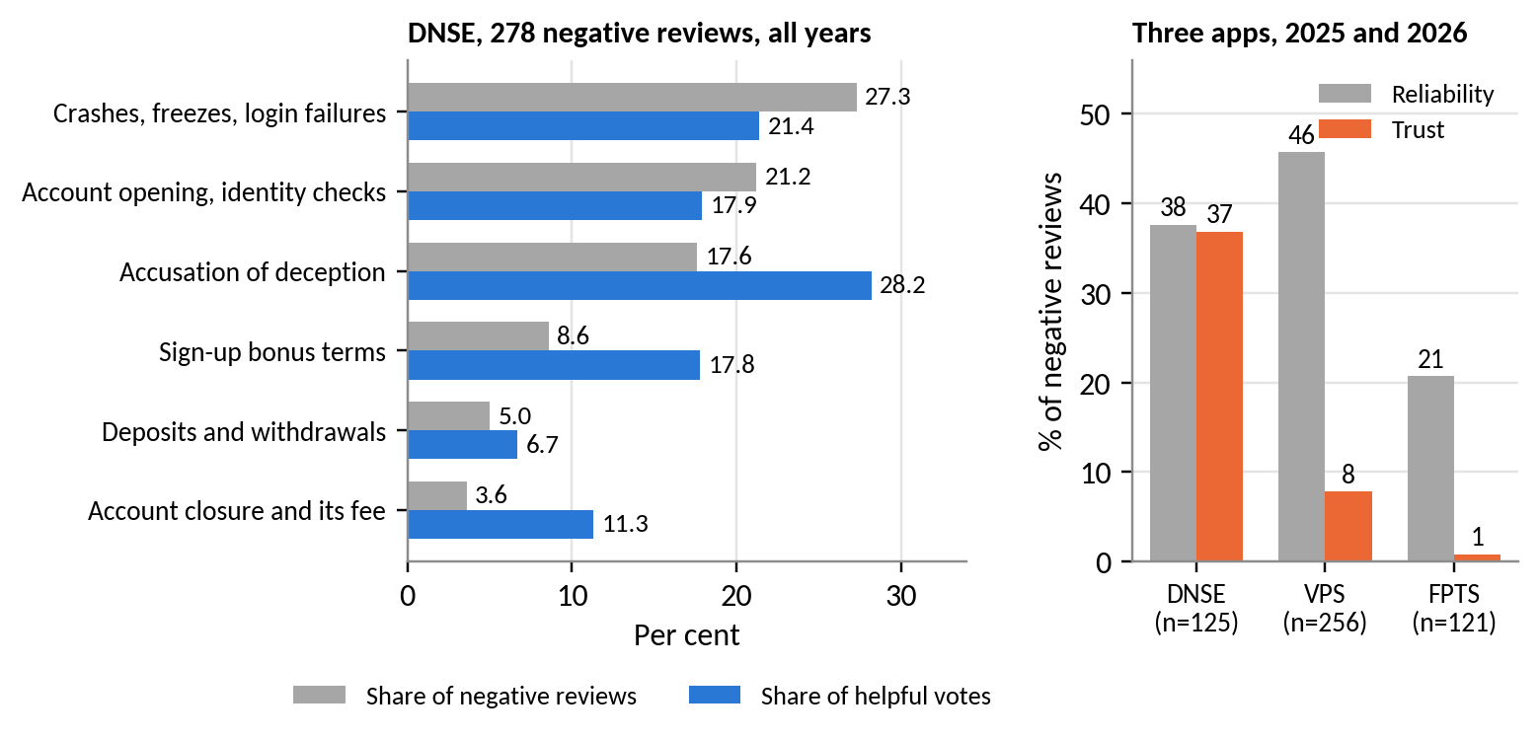
Figure 8. Complaint themes in negative Google Play reviews
Source: Google Play, retrieved 23 September 2026; authors' coding (Appendix D).
Insight. Trust complaints cluster at the first deposit and at withdrawal, the moments that decide funding.

2.7 Finding 6. Saving products exist but reach few customers
DNSE already has saving products, but few customers use them. Tài khoản không ngủ had 12,100 registered users at the end of 2025, 0.8 per cent of accounts, and Trứng Vàng had 1,037 active customers in December (DNSE Securities, 2026c). Population data point to demand that is not acted on. Among Vietnamese adults, 70.5 per cent hold an account and 43.1 per cent save at a financial institution (World Bank, 2025). The richest 60 per cent, adults in the labour force and adults with secondary education rank in the top four segments under all four weighting schemes, each with 15 to 20 million adults who have an account and no formal saving (Figure 9). Among investors, 36 per cent know a digital wealth platform, 16 per cent use one and 77 per cent find portfolio management difficult (Nhân Dân, 2025; VnEconomy, 2025).
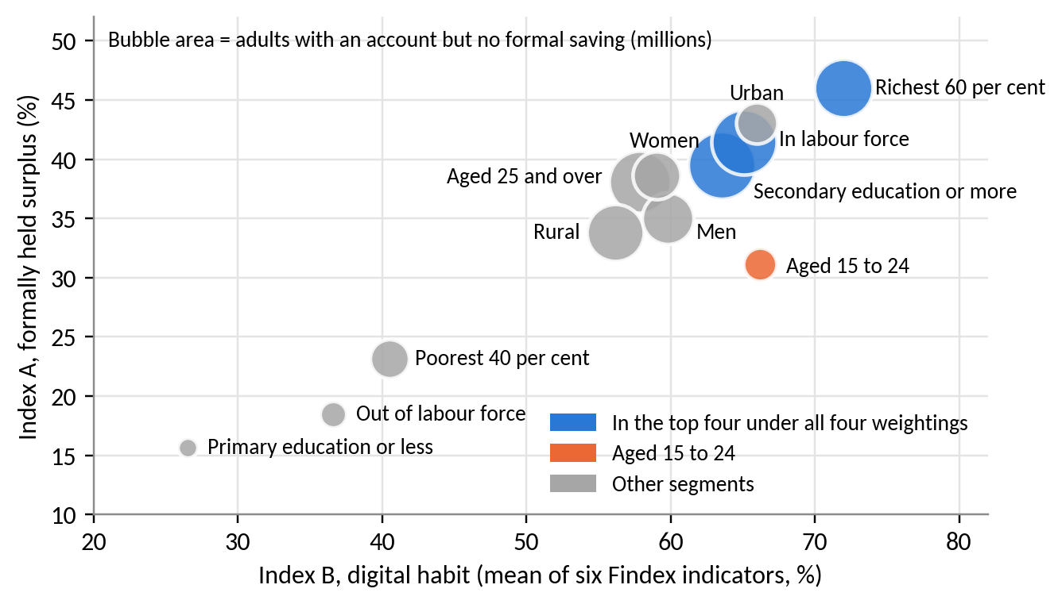
Figure 9. Vietnamese adult segments by digital habit and formally held surplus
Source: World Bank (2025); authors' indices (Appendix E).
Hypothesis. Many savers, probably including many DNSE account holders, have an income, an account and an intention to invest but do not act. The pattern is consistent with procrastination (O'Donoghue & Rabin, 1999).

3. Discussion and main analysis

3.1 From symptom to root cause
Zero-fee acquisition makes opening an account costless, so a sign-up carries no commitment to fund it. Figure 10 traces three root causes, each with a different strength of evidence.
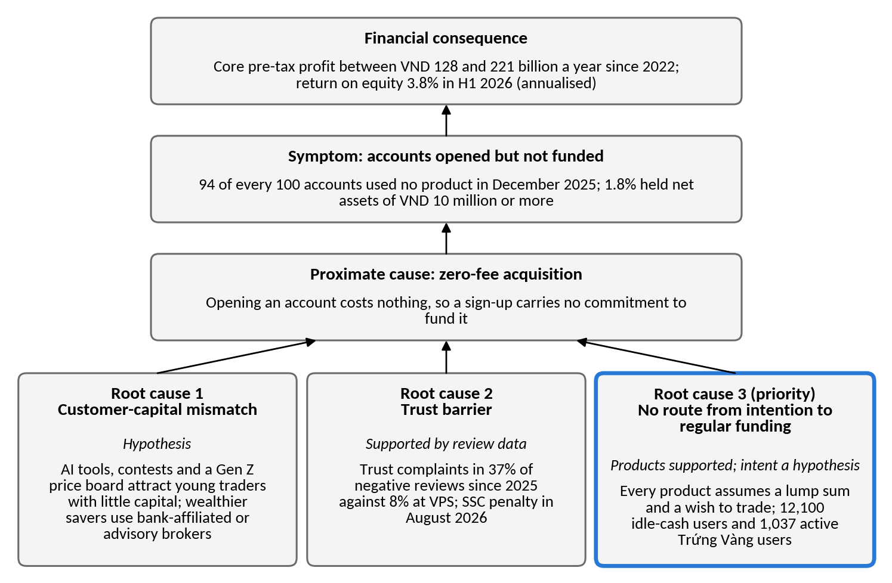
Figure 10. Root-cause tree for unfunded accounts
Source: authors' analysis of Section 2.
The customer-capital mismatch is a hypothesis. Gen Z customers held 31.5 per cent of DNSE's accounts in mid-2025 (VnExpress, 2025), 81 per cent of investors want professional advice (Nhân Dân, 2025), and DNSE serves customers through its app without human brokers. The trust barrier is supported by the review comparison in Finding 5. The missing route from intention to regular funding is supported for products and remains a hypothesis for customers. No DNSE product sets a schedule, a goal or a default, and when each contribution is a fresh decision, people who intend to save keep postponing. Automatic enrolment raised pension-plan participation from 37 to 86 per cent (Madrian & Shea, 2001), and pre-committed saving raised saving rates from 3.5 to 13.6 per cent (Thaler & Benartzi, 2004).
Four alternative explanations were tested (Table F3). The market cycle, a shortage of lending capital and dormancy common to all brokers do not fit the data. A deliberate plan to earn from young customers later cannot be rejected without cohort data.

3.2 Target segments
The sizes and barriers in Table 1 are hypotheses for internal data to test. The scale-up segment will grow, since KPMG Vietnam (2025) expects 68.2 per cent of households to earn more than USD 5,000 a year by 2028.
Table 1. Customer segments and objectives
Segment (E existing, N new) | Main barrier (hypothesis) | Objective
E1. Active and funded (85,739 active; 27,100 above VND 10 million) | Reliability; rivals' yields | Retain; add a goal
E2. Dormant intenders (about 1.4 million accounts below VND 10 million) | Procrastination; reward disputes | Launch target
N1. Salaried adults aged 22 to 40 (15 to 20 million account holders who do not save formally) | No route from salary to investment | Scale-up target
N2. First-time investors aged 15 to 24 | Low capital; irregular income | Build habits cheaply
N3. Older, wealthy investors | Prefer human brokers and bank brands | Deprioritise
Source: Sections 2.2 and 2.7; World Bank (2025).

3.3 Problem prioritisation
In Table 2 the funding gap ranks first under the stated weights and ties with trust under equal weights. Under 20,000 random weightings each leads in about half of the draws, and no other problem leads in more than 6 per cent (Table F2). The top two lead in 94 per cent of the draws, and their order depends on the weight given to scale.
Table 2. Candidate problems scored from 1 (weak) to 5 (strong)
Problem | Scale anchor | Scale (30%) | Urgency (15%) | Control (25%) | Cost of fix (15%) | Evidence (15%) | Weighted | Equal
Funding gap in existing accounts | 1.4 million accounts below VND 10 million | 5 | 4 | 4 | 5 | 3 | 4.30 | 4.20
Trust and reliability deficit | 37% of negative reviews since 2025 | 3 | 5 | 5 | 4 | 4 | 4.10 | 4.20
Loss-making brokerage and platform | VND 89 billion a year below direct cost | 3 | 4 | 3 | 3 | 5 | 3.45 | 3.60
Customer-capital mismatch | Largest pool of money; slow to change | 5 | 3 | 2 | 1 | 3 | 3.05 | 2.80
Expensive, collateralised funding | About VND 130 billion a year since 2025 | 4 | 4 | 1 | 1 | 3 | 2.65 | 2.60
Source: authors' assessment; anchors in Appendix F. Higher cost-of-fix scores mean cheaper fixes.
The two problems meet at the first deposit, and trust repairs alone create no deposits. We therefore prioritise the funding gap and make trust a design condition. The gap is urgent. Deposit rates are rising, cash is leaving brokers, open banking will let every competitor link salary accounts from March 2027, and DNSE had delivered 20 per cent of its 2026 profit target by mid-year (Vietstock, 2026a).
Problem statement. Most DNSE accounts are never funded. At the end of 2025, 98 per cent held less than VND 10 million, so fewer than 2 in 100 carried the platform's cost. No DNSE product turns an intention to invest into regular deposits, and trust complaints deter the first deposit. Customers earn less than inflation on idle cash, and shareholders earn 3.8 per cent on equity.

3.4 Strategic alternatives and trade-offs
Table 3. Strategic alternatives scored from 1 (weak) to 5 (strong)
Option | Funded balances (30%) | Low cost (20%) | Reuses assets (15%) | Trust fit (15%) | Speed (10%) | Evidence (10%) | Weighted | Equal | Main sacrifice
B. Payday Portfolio with trust package | 5 | 3 | 5 | 4 | 2 | 4 | 4.05 | 3.83 | Speed
A. Trust and reliability programme only | 2 | 4 | 4 | 5 | 4 | 3 | 3.45 | 3.67 | No funding mechanism
D. Reprice Tài khoản không ngủ | 3 | 1 | 5 | 3 | 5 | 3 | 3.10 | 3.33 | VND 20 billion a year per point
C. Advisory tier with human brokers | 4 | 1 | 1 | 3 | 2 | 3 | 2.50 | 2.33 | Advisers DNSE lacks
E. More sign-up rewards (status quo) | 1 | 2 | 5 | 1 | 4 | 2 | 2.20 | 2.50 | Accounts stay unfunded
Source: authors' assessment. A higher cost score means a lower cost.
Payday Portfolio (B) ranks first under both weightings and in 54 per cent of random weightings, against 33 per cent for a trust programme alone (A). B includes A as its first phase and adds the mechanism that brings money in. Repricing the idle-cash account (D) costs about VND 20 billion a year per point on existing cash, and banks already pay 6.8 per cent. An advisory tier (C) competes with established bank-affiliated rivals, and more sign-up rewards (E) repeat the pattern that produced the gap. B sacrifices speed, since balances build month by month and cannot rescue the 2026 profit plan.

4. Recommendations

4.1 Payday Portfolio
We recommend Payday Portfolio, an automatic, goal-based investing plan for salaried customers who intend to invest but keep postponing. It starts with dormant account holders who receive a salary (E2) and extends to new salaried customers (N1) after the pilot. The customer sets a goal and a monthly amount from VND 500,000 once (Figure 11). A standing order in the customer's banking app, or through ZaloPay, a DNSE partner since 2023 (Thanh Niên, 2023), moves the money on payday, so DNSE never debits a bank account. Cash waits briefly in Tài khoản không ngủ and is then invested in Trứng Vàng bonds by default, or in funds and VN30 exchange-traded funds by opt-in. Ensa sends payday reminders, since reminders raised saving in field experiments (Karlan et al., 2016). Margin is excluded at launch.
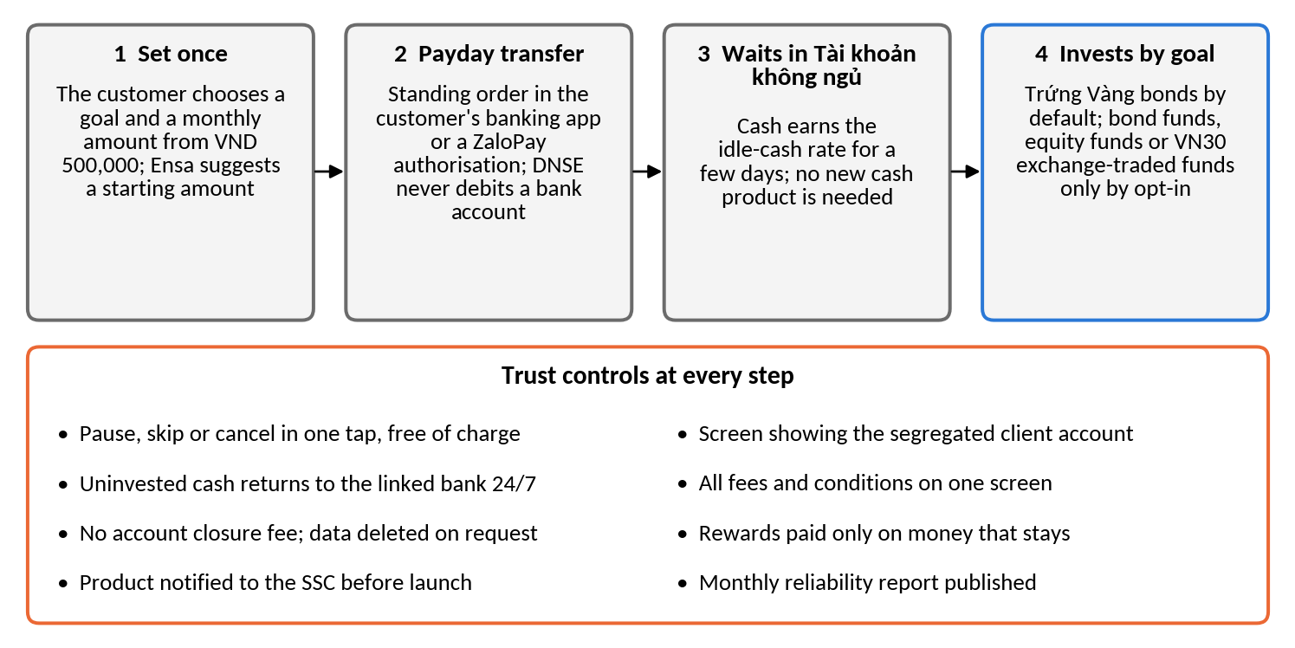
Figure 11. How Payday Portfolio works
Source: authors' design.
Trust blocks a large one-off commitment, and Payday Portfolio asks for none. Each small transfer that arrives safely and can be withdrawn at once gives the customer direct evidence that money moves in and out safely. For a customer who procrastinates, the obstacle is the monthly decision, so we expect automation to work better than a higher yield, which test 2 in Table 5 checks. Launch requires prior notice to the State Securities Commission, a licensed fund partner and transfers that succeed 99.5 per cent of the time. Each trust control has a published measure (Table F5).

4.2 Value logic and scenarios
Payday Portfolio earns fees on bonds, funds and exchange-traded funds, but its larger effect is on cost and capital. It reuses verified accounts, the idle-cash account, Trứng Vàng, ZaloPay and Ensa, so the new build is limited to scheduling and goal tracking. In the base case, accounts with VND 10 million or more rise from 27,100 to about 177,000, cutting platform cost per funded account from VND 7.3 million to about VND 1.1 million before new costs. Fee income on these balances needs no new pledged borrowing, unlike margin growth (Finding 3). Base-case fees of VND 23 billion equal 1.6 per cent of 2025 revenue, so the value lies in balances and unit costs (Table 4).
Table 4. Outcomes 18 months after launch (all inputs are assumptions)
 | Conservative | Base | Upside
Savers enrolled | 60,000 | 150,000 | 300,000
Monthly contribution, VND million | 1.0 | 1.5 | 2.5
Share of contributions kept | 60% | 70% | 80%
Assets, VND trillion (multiple of investor cash) | 0.65 (0.3) | 2.84 (1.4) | 10.80 (5.5)
Annual fees, VND billion | 3 | 23 | 108
Accounts with VND 10 million or more (share of mid-2026 base) | 87,100 (5.1%) | 177,100 (10.4%) | 327,100 (19.2%)
Source: authors' projections (Appendix F; Figure F1).

4.3 Validation direction
Table 5 ranks the assumptions by the damage they would cause if wrong. The headline KPI is the number of accounts holding VND 10 million or more, which DNSE already reports. It was 27,100 (1.8 per cent of accounts) at the end of 2025, and the target is 85,000 within 18 months, 5 per cent of the mid-2026 base. A count is not diluted by new sign-ups. Supporting KPIs are the monthly active rate (5.7 per cent), net new money, cost per funded account (VND 7.3 million) and the trust share of negative reviews (37 per cent).
Table 5. Priority assumptions, tests and thresholds for Round 3
# | Assumption | Test | Threshold to proceed
1 | Many dormant accounts belong to salaried intenders | Internal data; survey of 2,000 customers | 30% or more intend to invest
2 | Automation turns intention into funding | Randomised pilot, 20,000 customers, against a standard message | 15% enrol in 60 days; 70% of money kept at day 90
3 | Trust features raise set-up | A/B test of the trust screen | Set-up completion up 5 points
4 | A compliant structure exists (gate) | SSC pre-consultation; fund-partner terms | Written confirmation
5 | Transfers are reliable (gate) | Load tests; shadow payday runs | 99.5% transfer success
6 | Unit costs fall | Incremental cost against new balances | Below VND 7.3 million per funded account
7 | Inflows are new money | Tag the source of each inflow | 80% or more new money
Source: authors' design.
DNSE should scale only if tests 1 to 3 pass and both gates hold. If enrolment falls short while retention holds, the message changes, and if retention fails, the concept stops (Figure 12).
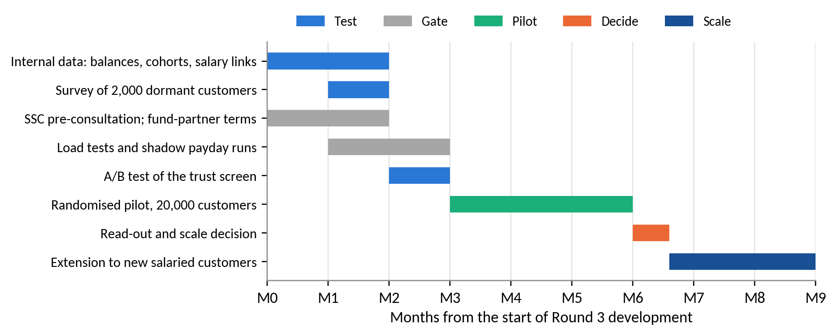
Figure 12. Validation roadmap for Round 3
Source: authors' design.

5. Conclusion
DNSE acquires customers at scale, but fewer than 2 in 100 accounts carry its free trading, its platform and its costly borrowing. The customer base holds little capital, trust complaints are specific to DNSE, and no product turns an intention to invest into regular deposits. Payday Portfolio acts on the cause DNSE controls most. It builds trust in small, reversible steps and reuses infrastructure DNSE has already paid for. Round 3 should first measure who the dormant customers are and then run a randomised pilot.

Appendices

Appendix A. Data preparation and quality
Table A1. Evidence base and preparation
Dataset | Coverage | Main preparation step | Remaining limitation
DNSE filed statements | 395 line items, first quarter of 2018 to second quarter of 2026 | Pulled line by line from Vietcap IQ; reconciled to the half-year statements reviewed by KPMG | Template line 24 mixes provisions with borrowing cost
DNSE annual report 2025 | Accounts, active customers, net-asset bands, product users | Figures read from the report and dated | Company-defined measures; active means at least one product used in the month
Peer statements and indicators | Four peers; accounts, lending, funding, profit | Same cost-of-funds method as for DNSE; each figure dated | Account counts differ in date and definition
Exchange and industry data | HOSE and HNX shares; industry lending, investor cash and profit | Each share kept within its own exchange; broadest industry total used | Press tallies differ slightly in coverage
App store reviews | 867 Google Play and 332 App Store reviews of DNSE; 2,100 of VPS and FPTS | Spam and duplicates removed; one-word reviews flagged; themes coded | Self-selected sample; levels overstate dissatisfaction
World Bank Global Findex 2024 | 51 indicators across 13 segments for Vietnam | Two indices built; segment weights recovered from the survey | About 1,000 interviews; one dimension at a time
Macro and banking data | Growth, inflation, credit, deposit rates, deposits | Dated at source; projections labelled | Some series reported only through the press
Source: compiled by the authors; access dates 20 to 25 September 2026.
A1. Reconciliation. Where press reports and the filings differ, the reviewed filings are used (Table A2). The half-year statements reviewed by KPMG raise administrative expenses by VND 1.5 billion against the quarterly statement of 20 July 2026. The press figure of VND 1,467 billion for 2025 revenue includes financial income, and the filings report VND 1,457.9 billion of operating revenue.
Table A2. Press figures reconciled with the filings, VND billion
Item | Press or earlier data pack | Filings used | Reason for the difference
Pre-tax profit, Q2 2026 | 98.9 | 97.4 | Reviewed half year less the first quarter
Pre-tax profit, H1 2026 | 113.1 | 111.6 | Reviewed statements of 14 August 2026
Operating revenue, 2025 | 1,467.0 | 1,457.9 | Press total includes financial income
Revenue growth, 2025 | 77% | 80.6% | Follows from the line above
Proprietary provisions, Q1 2026 | plus 405% | not used | No line of the filings reproduces the figure
Source: DNSE filings via Vietcap Securities (2026); DNSE Securities (2026a); press reports cited in Section 2.
A2. Transformations. The cost of funds equals interest expense plus template line 24, less the rise in the balance-sheet allowance for loan losses, multiplied by four and divided by average borrowings and bonds. The net interest margin deducts this cost from interest on loans, deposits and bonds held to maturity, over average interest-earning assets. Core pre-tax profit excludes the net result on financial assets at fair value through profit or loss. Per-account values divide a balance or flow by accounts at the same date. The same formulas are applied to peers.
A3. Concentration bound. At the end of 2025 DNSE reported 1,512,920 accounts, of which 27,100 held net assets of VND 10 million or more, and customer assets of VND 53,471 billion. The other 1,485,820 accounts each hold less than VND 10 million net, or at most VND 14,858 billion together. Their gross assets can exceed net assets only by what they borrow, and total lending was VND 5,832 billion. They can therefore hold at most VND 20,690 billion, so accounts with VND 10 million or more hold at least VND 32,781 billion, or 61 per cent of customer assets. The bound is conservative because it assigns every loan to the smaller accounts.
A4. Denominators, missing values and outliers. HOSE and HNX report market share within their own exchange, so shares are never compared across exchanges. Industry lending (VND 453.8 trillion including advances) and investor cash (VND 86.6 trillion) use the broader published totals, and narrower totals raise DNSE's shares by about 0.1 point. The industry cash total for the fourth quarter of 2025 and DNSE's derivatives share for the second and third quarters of 2024 were not published and are left missing. DNSE's investor cash fell to VND 429 billion in the first quarter of 2025 and recovered the next quarter. The value appears in the filings and probably reflects settlement timing. It stays in the series and is excluded from trend statements.
A5. Platform cost proxy. DNSE does not report technology spending. The proxy sums staff costs and outsourced services from the note on general and administrative expenses and total depreciation and amortisation from the cash flow statement. It may include non-technology overheads and exclude technology staff costs booked under brokerage expenses, so it is used for trend and order of magnitude only.
Table A3. Review cleaning log
Stage | DNSE, Play | VPS, Play | FPTS, Play | DNSE, iOS | VPS, iOS | FPTS, iOS
Reviews retrieved | 867 | 1,200 | 177 | 332 | 518 | 205
Loan advertising removed | 127 | 23 | 0 | 0 | 0 | 0
Referral farming removed | 70 | 3 | 0 | 73 | 6 | 0
Duplicates removed | 0 | 3 | 0 | 0 | 0 | 0
Reviews retained | 670 | 1,171 | 177 | 259 | 512 | 205
Mean rating before cleaning | 3.29 | 2.60 | 2.18 | 3.37 | 1.57 | 2.31
Mean rating after cleaning | 3.22 | 2.58 | 2.18 | 2.94 | 1.53 | 2.31
Source: Google Play (23 September 2026) and Apple App Store (24 September 2026); authors' cleaning code. Text was normalised (Unicode compatibility composition, diacritics removed, lower case) before two rules flagged loan advertising and referral farming. The referral rule fires only where a referral phrase sits next to a code or reward amount and passes 37 test cases. Copy-and-paste duplicates of 20 characters or more were removed, and identical short reviews by different people were kept. VPS is its 1,200 most recent Google Play reviews, from 27 March 2023.
Cleaning changed the conclusions. In 2022 and 2023, 46 and 54 per cent of DNSE's Google Play reviews were spam, and the removed material was rated higher than the genuine reviews (3.53 against 3.22), so cleaning lowers DNSE's rating. Table A4 tests the rule that flags generic reviews.
Table A4. Sensitivity of the generic-review rule, DNSE Google Play
Rule for a generic review | Generic share, 2024 | Generic share, 2025 | Substantive mean, 2024 | Substantive mean, 2025
One word (rule used) | 33.7% | 12.0% | 4.15 | 2.38
Up to two words | 50.3% | 17.7% | 4.00 | 2.22
Up to four words | 62.7% | 25.9% | 3.74 | 2.01
Source: authors' cleaning code. The fall in substantive ratings from 2024 to 2025 holds under every rule.

Appendix B. DNSE financial data
Table B1. Income statement summary, VND billion
Item | 2021 | 2022 | 2023 | 2024 | 2025 | H1 2026
Operating revenue | 180.7 | 452.1 | 714.5 | 807.4 | 1,457.9 | 848.2
Interest on margin loans and advances | 42.7 | 223.1 | 286.2 | 360.5 | 555.8 | 336.1
Interest on deposits and bonds held to maturity | 20.1 | 112.9 | 196.0 | 245.0 | 303.9 | 193.4
Brokerage revenue | 90.0 | 84.8 | 67.6 | 144.8 | 404.0 | 222.1
Direct brokerage cost | 51.5 | 74.4 | 111.1 | 174.8 | 464.9 | 266.5
Interest expense plus line 24 | 23.9 | 172.2 | 233.6 | 210.6 | 429.8 | 324.1
Administrative expenses | 14.8 | 37.1 | 94.3 | 151.9 | 181.4 | 95.4
Pre-tax profit | 68.2 | 95.0 | 285.6 | 227.5 | 340.2 | 111.6
Net proprietary result | (4.4) | (61.3) | 158.0 | 6.8 | 146.2 | 33.9
Core pre-tax profit | 72.5 | 156.3 | 127.6 | 220.7 | 194.0 | 77.7
Source: DNSE filed statements via Vietcap Securities (2026); H1 2026 from the half-year statements reviewed by KPMG; authors' calculations. Core pre-tax profit excludes the net result on financial assets at fair value through profit or loss. Negative values are in parentheses.
Table B2. Balance sheet and main ratios
Item | 2021 | 2022 | 2023 | 2024 | 2025 | Jun 2026
Margin loans and advances, VND bn | 1,192 | 2,280 | 2,483 | 3,882 | 5,832 | 6,303
Deposits and bonds held to maturity, VND bn | 883 | 2,824 | 3,495 | 5,103 | 6,266 | 5,714
Total assets, VND bn | 2,315 | 6,409 | 7,446 | 10,637 | 15,139 | 15,208
Borrowings and bonds, VND bn | 1,224 | 2,735 | 3,643 | 6,494 | 10,600 | 9,446
Owners' equity, VND bn | 1,059 | 3,136 | 3,305 | 4,030 | 4,302 | 5,440
Investor cash (off balance sheet), VND bn | 435 | 251 | 790 | 1,340 | 2,903 | 1,961
Pre-tax margin, % | 37.7 | 21.0 | 40.0 | 28.2 | 23.3 | 13.2
Brokerage revenue as % of direct cost | 174.9 | 114.0 | 60.9 | 82.8 | 86.9 | 83.3
Return on equity, % | 8.9 | 3.7 | 7.1 | 5.0 | 6.5 | 3.8
Loans as % of equity (ceiling 200) | 112.6 | 72.7 | 75.1 | 96.3 | 135.6 | 115.9
Estimated cost of funds, % | 6.5 | 6.8 | 7.3 | 4.1 | 5.1 | 6.3
Net interest margin, % | 6.2 | 5.4 | 4.8 | 5.0 | 4.2 | 3.5
Source: as Table B1. Return on equity, cost of funds and net interest margin in the last column cover the first half of 2026, annualised. Section 2.4 and Table C2 quote the second quarter alone, when the cost of funds was 6.5 per cent.
Table B3. Platform and overhead cost proxy, VND billion
Item | 2021 | 2022 | 2023 | 2024 | 2025
Staff costs (administration) | 8.6 | 12.1 | 41.2 | 80.0 | 99.4
Outsourced services | 4.8 | 21.5 | 40.4 | 52.8 | 62.7
Depreciation and amortisation (all) | 2.4 | 5.0 | 16.2 | 25.9 | 35.4
Platform cost proxy | 15.8 | 38.7 | 97.8 | 158.8 | 197.5
Software and leased equipment at cost | 20.0 | 44.7 | 95.7 | 129.1 | 168.5
Accounts at year end | 44,727 | 189,845 | 561,279 | 994,811 | 1,512,920
Active customers, December | n.a. | n.a. | n.a. | about 41,900 | 85,739
Proxy per active customer, VND million | n.a. | n.a. | n.a. | 3.79 | 2.30
Source: DNSE filed statements (notes on administrative expenses; cash flow statement; notes on intangible and finance-lease assets); DNSE Securities (2026c); authors' calculations.
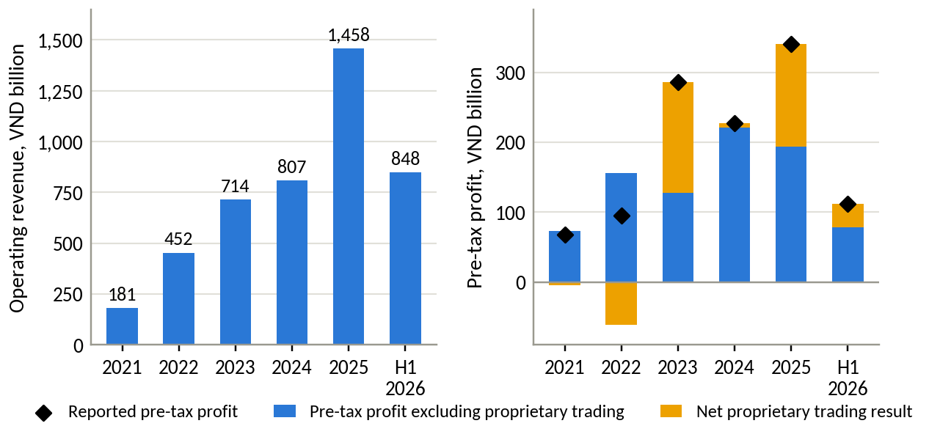
Figure B1. Operating revenue and pre-tax profit split into core business and proprietary trading
Source: DNSE filings; authors' calculations.
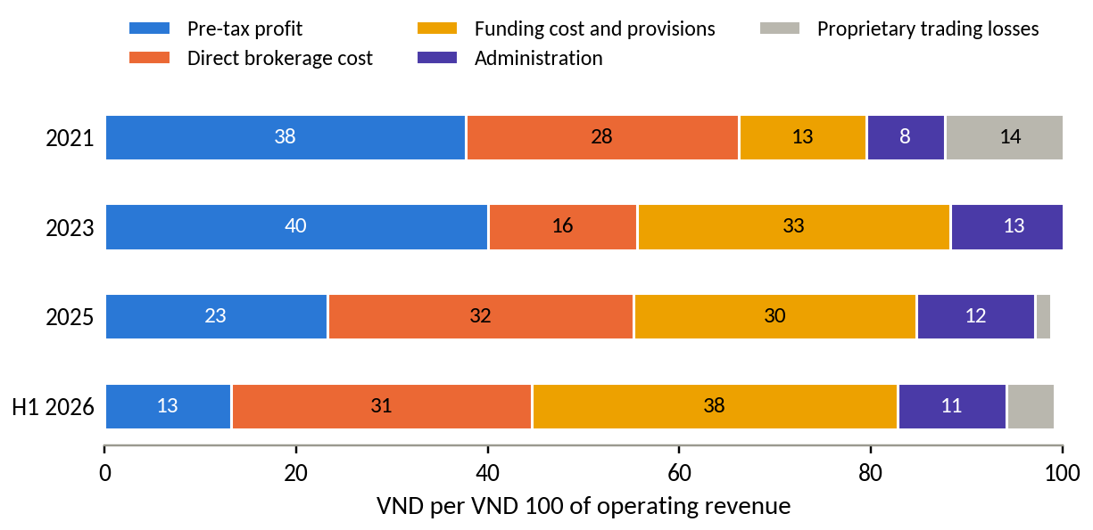
Figure B2. Where each VND 100 of operating revenue goes
Source: DNSE filings; authors' calculations.
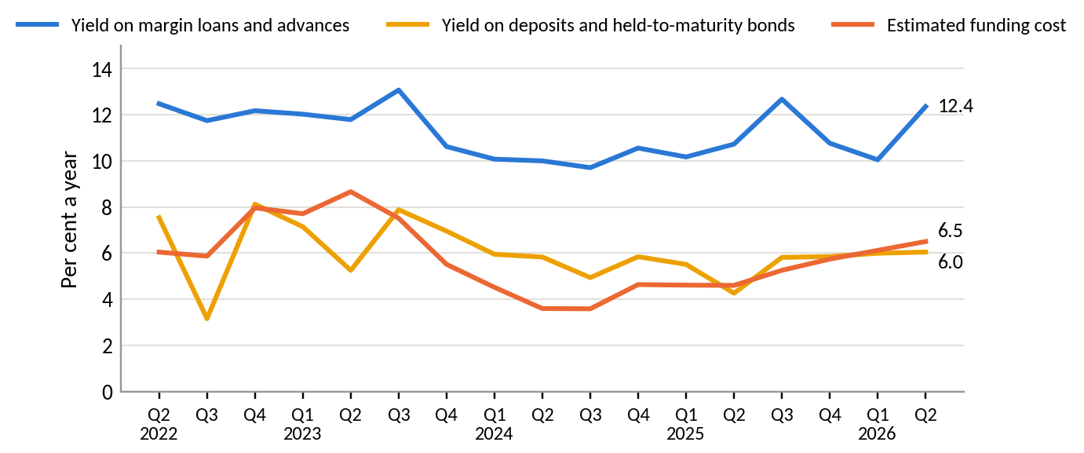
Figure B3. Yield on margin loans and on deposits and bonds held to maturity, against the estimated cost of funds
Source: DNSE filings; authors' calculations.
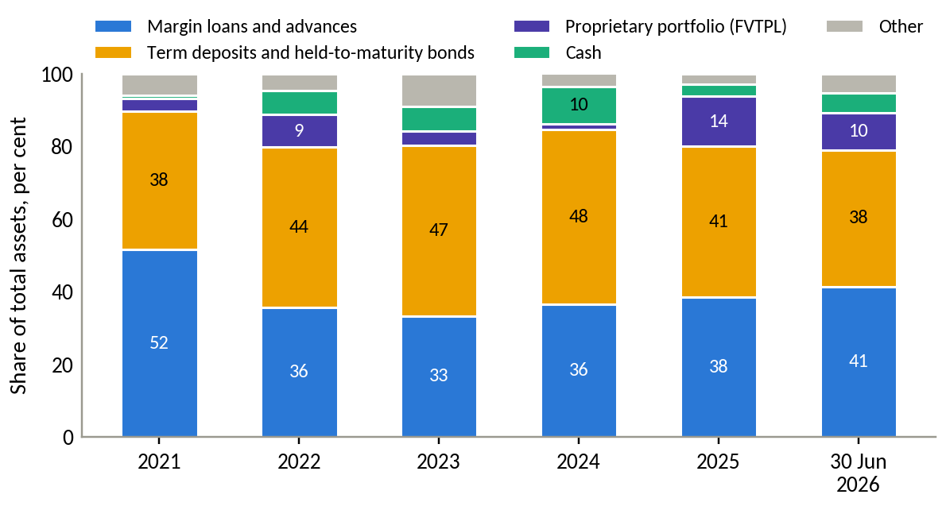
Figure B4. Composition of DNSE total assets
Source: DNSE filings.

Appendix C. Market and peer data
Table C1. DNSE's position on eight measures
Measure | DNSE | Market total | DNSE share, % | Ratio to account share
Securities accounts, mid-2026 | 1.70 million | 13.85 million | 12.27 | 1.00
New accounts, 2025 | 518,514 | 2,573,945 | 20.14 | 1.64
Derivatives brokerage, Q2 2026 | 2nd place | HNX | 25.38 | 2.07
Listed-share brokerage on HNX, Q2 2026 | 8th place | HNX | 2.88 | 0.23
Cash equity trading, Q2 2026 (estimate) | VND 62.9 trillion | all exchanges | 2.1 to 2.6 | 0.17 to 0.21
Investor cash at brokers, 30 June 2026 | VND 1,961 billion | VND 86.6 trillion | 2.26 | 0.18
Margin lending, 30 June 2026 | VND 6,303 billion | VND 453.8 trillion | 1.39 | 0.11
Pre-tax profit, Q2 2026 | VND 97.4 billion | VND 15,200 billion | 0.64 | 0.05
Source: VnExpress (2026a); DNSE Securities (2026c); Vietstock (2026c); CafeF (2026); VnEconomy (2026); Hanoi Stock Exchange (2026); DNSE filings; authors' calculations. The trading estimate divides the value of shares DNSE's customers traded by twice the value traded on HOSE plus 7 per cent for HNX and UPCoM.
Table C2. DNSE against named peers
Indicator | DNSE | VPBankS | TCBS | VPS
Customer accounts, million | 1.70 | 1.30 | 1.20 | 1.55
Margin lending, 30 June 2026, VND bn | 6,303 | 38,200 | 51,500 | 31,300
Lending per account, VND million | 3.7 | 29.4 | 42.9 | 20.2
Pre-tax profit per account, Q2 2026, VND thousand | 57 | 1,661 | 1,748 | 891
Deposits and bonds held to maturity, % of assets | 37.6 | 6.5 | 4.6 | 4.3
Estimated cost of funds, Q2 2026, % | 6.5 | 6.8 | 7.8 | 5.1
Parent bank | none | VPBank | Techcombank | none
Source: filed statements via Vietcap Securities (2026); company releases for account counts (VPBankS May 2026; TCBS end-2025; VPS September 2025); Vietstock (2026c); authors' calculations. Per-account values are averages that large clients raise at every firm. SSI, with no parent bank, holds 8.6 per cent of assets in deposits and bonds and has a cost of funds of 6.1 per cent.
Table C3. Competitive landscape of Vietnamese retail brokerage and savings
Model | Examples | How it earns | Strength | Gap for salaried savers
Bank-affiliated brokers | TCBS, VPBankS, MBS | Margin lending, bond distribution | Cheap funding, capital, parent-bank customers and trust | Serve mainly their parents' customers; TCBS iPower pays interest only above VND 5 million
Independent full-service brokers | SSI, HSC, Vietcap | Margin, institutional brokerage, advisory | Research, brand, human brokers | Costly to serve small savers
Retail trading platforms | VPS | Retail and derivatives brokerage, margin | Largest retail share | Trading-first; no link from a salary
Zero-fee digital brokers | DNSE, Pinetree | Margin, derivatives | Low cost, fast technology, young customers | Small balances; no regular-saving product
Banks' automatic-earning accounts | Large commercial banks | Deposit spread | Salary accounts, trust | Little choice beyond deposits
Source: company statements and product pages; TCBS (2026); Vietstock (2026b); authors' assessment.
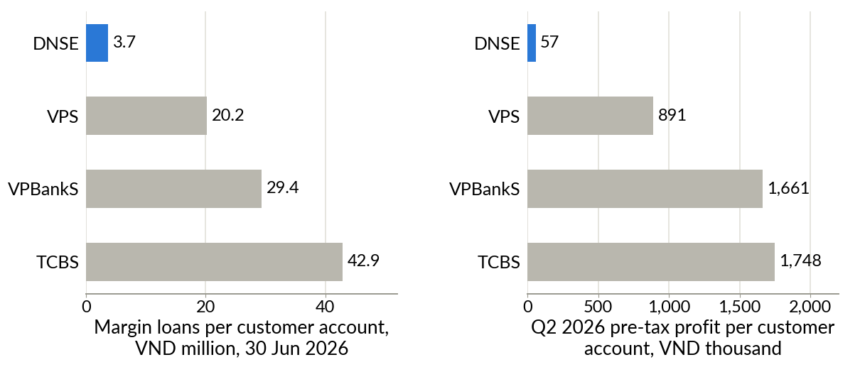
Figure C1. Lending and profit per customer account, DNSE against VPS, VPBankS and TCBS
Source: as Table C2.

Appendix D. Customer review analysis
Table D1. Themes in DNSE's negative Google Play reviews
Theme | Negative reviews | Share of negative reviews, % | Share of helpful votes, %
Crashes, freezes, login failures, slow orders | 76 | 27.3 | 21.4
Account opening, identity checks, one-time passwords | 59 | 21.2 | 17.9
Explicit accusation of deception | 49 | 17.6 | 28.2
Sign-up bonus terms, rewards not received | 24 | 8.6 | 17.8
Deposits not credited, withdrawal delays | 14 | 5.0 | 6.7
Cannot close the account, closure fee | 10 | 3.6 | 11.3
Any trust theme (deception, bonus terms, closure) | 67 | 24.1 | 42.9
Any product theme (stability, onboarding) | 118 | 42.4 | 34.1
Idle-cash product (Tài khoản không ngủ), all reviews | 3 mentions, all positive
Source: Google Play, retrieved 23 September 2026; authors' coding. 278 one- and two-star reviews carrying 1,794 helpful votes. Themes are not exclusive.
Table D2. Reliability and trust complaints at three brokers, January 2025 to September 2026
Application | Negative reviews | Reliability, % of reviews | Reliability, % of votes | Trust, % of reviews | Trust, % of votes | App Store mean, 2025 to 2026
DNSE Entrade X | 125 | 37.6 | 30.2 | 36.8 | 50.4 | 2.25
VPS SmartOne | 256 | 45.7 | 45.1 | 7.8 | 7.3 | 1.47
FPTS EzTrade | 121 | 20.7 | 17.7 | 0.8 | 1.8 | 2.31
Source: Google Play (retrieved 23 September 2026) and Apple App Store (retrieved 24 September 2026); authors' cleaning and coding. Reliability covers crashes, freezes, login failures, slow orders and account opening. Trust covers accusations of deception, sign-up bonus terms and account closure.
Table D3. Selected DNSE reviews, translated from Vietnamese
Date | Stars | Helpful votes | Review
9 Jun 2025 | 1 | 58 | "Everyone, be careful, it is a scam. You do not receive the 100k. To delete your account you have to pay it 100k."
24 May 2025 | 1 | 54 | "I have been trapped ... you cannot cancel the registration ... after approval you have to go to the head office to delete the account."
28 Jun 2025 | 1 | 50 | "Deceptive and false. There is no 100k straight away. You have to deposit at least 2 million to get it."
2 Jun 2025 | 2 | 18 | "When I deposit outside trading hours, the money leaves my bank account but the securities account does not receive it."
15 May 2026 | 5 | 13 | "... The idle account is the best. Watching the interest rise in real time is satisfying, and money earns interest automatically once it is deposited."
Source: Google Play; translated by the authors.
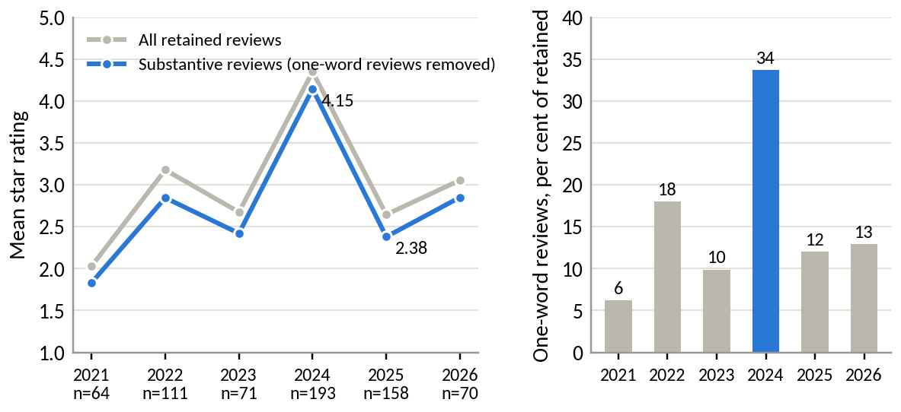
Figure D1. Mean rating of DNSE reviews by year, and the share of one-word reviews
Source: Google Play; authors' cleaning.
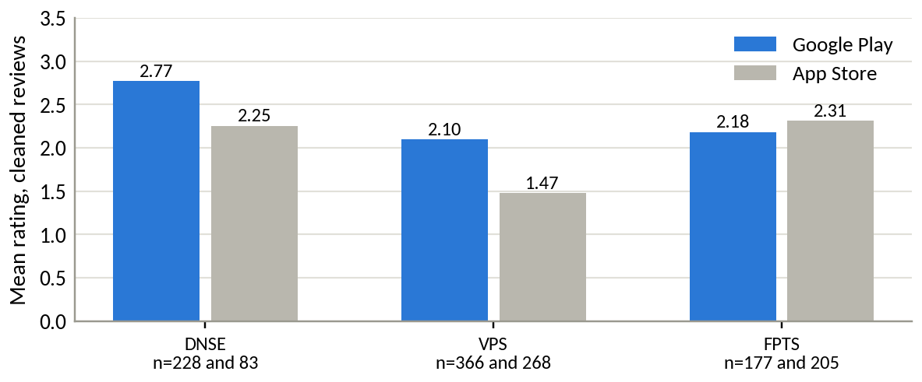
Figure D2. Mean rating of cleaned reviews on Google Play and the App Store, 2025 and 2026
Source: Google Play and Apple App Store; authors' cleaning.
Regulatory record. Decision 461/QĐ-XPHC of the State Securities Inspectorate, issued on 17 August 2026, fined DNSE VND 802.5 million. The largest item, VND 275 million, concerned three services supporting derivatives brokerage (advances against open-position gains, out-of-hours advances on margin withdrawals and advances of margin deposits), offered from January 2024 to June 2026 without reporting to the State Securities Commission. DNSE was ordered to stop all three. Other items covered margin loans and advances to insiders and related persons from January 2024 to June 2026, buy orders placed without sufficient funds, margin trading beyond purchasing power and loans for securities that did not qualify (Market Times, 2026; Phụ nữ Việt Nam, 2026). An earlier fine of VND 125 million concerned margin lending on a stock removed from the marginable list (Thương hiệu & Công luận, 2024).

Appendix E. Findex segment analysis
Table E1. Findex indicators for selected segments, Vietnam, 2024 fieldwork (per cent of adults)
Segment | Share of adults | Index A (surplus) | Index B (digital) | Has an account | Saved at an institution | Account but no formal saving, million | Wages into an account | Saved for old age
All adults | 100.0 | 36.8 | 59.4 | 70.5 | 43.1 | 22.1 | 37.0 | 20.2
Aged 15 to 24 | 18.2 | 31.1 | 66.2 | 72.2 | 38.6 | 4.9 | 36.9 | 8.2
Aged 25 and over | 81.8 | 38.1 | 57.9 | 70.2 | 44.1 | 17.2 | 37.0 | 22.8
Secondary education or more | 88.8 | 39.5 | 63.5 | 75.2 | 46.7 | 20.4 | 40.4 | 21.7
Richest 60% | 60.0 | 46.0 | 72.0 | 85.5 | 53.8 | 15.3 | 49.5 | 26.5
In labour force | 79.9 | 41.5 | 65.1 | 77.9 | 48.4 | 19.0 | 45.2 | 23.2
Poorest 40% | 40.0 | 23.1 | 40.5 | 48.1 | 27.1 | 6.8 | 18.1 | 10.6
Source: World Bank (2025); authors' indices. Index A averages six indicators of formally held surplus (saving at an institution, monthly saving into an account, storing money in an account, receiving interest, saving for old age, covering two months without income). Index B averages six indicators of digital habit (digitally enabled account, daily internet use, smartphone, weekly card or mobile payment in store, checking a balance by phone, wages into an account). Segment population shares are recovered from the survey itself.
Table E2. Segment ranks under four weighting schemes
Segment | Equal weights | Value-heavy | Scale-heavy | Reach-heavy
Richest 60% | 1 | 1 | 1 | 1
In labour force | 2 | 2 | 2 | 2
Secondary education or more | 3 | 4 | 3 | 3
Urban | 4 | 3 | 5 | 4
Aged 25 and over | 5 | 5 | 4 | 6
Aged 15 to 24 | 9 | 9 | 9 | 7
Source: authors' calculations from Table E1 and the full twelve-segment data. Each criterion is min-max normalised across the twelve segments. Weights on (Index A, Index B, gap, adults with an account but no saving, wage receipt, saving for old age) are 1,1,1,1,1,1 (equal); 3,1,1,1,2,2 (value-heavy); 1,1,1,3,1,1 (scale-heavy); and 1,3,2,1,1,1 (reach-heavy). With about 1,000 interviews, the 15-to-24 group rests on roughly 180 respondents, so small differences in rank sit within sampling error.
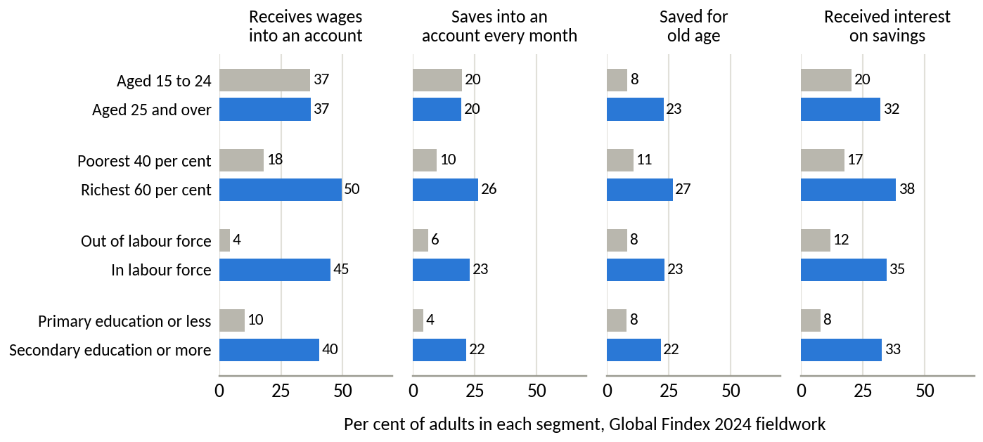
Figure E1. Payday and saving behaviour by segment pair
Source: World Bank (2025).

Appendix F. Assumptions, sensitivity and alternative explanations
Table F1. Register of assumptions and derived measures
Item | Type | Effect if wrong | How Round 3 tests it
Segment sizes and barriers (Table 1) | Hypothesis | Wrong target or message | DNSE internal data; Findex microdata; survey
Share of dormant accounts held by intenders | Hypothesis | Enrolment falls short | Test 1 (survey and internal data)
Automation and trust features raise funding | Hypothesis supported by research abroad | Concept fails the pilot | Tests 2 and 3
Scenario inputs (savers, contribution, retention, fee yield) | Assumption | Outcomes change in proportion | Pilot read-out at month 6
Platform cost proxy | Derived proxy | Level may be over- or understated; trend reliable | DNSE management accounts
Cost of funds for DNSE and peers | Derived | Line 24 may include more provisions than assumed | Notes on borrowing terms
Account counts differ in date and definition | Measured, mixed dates | Per-account values shift by up to about 10 per cent | Internal account register
App reviews are self-selected | Measured, biased sample | Levels overstate dissatisfaction; comparisons across themes and apps are more reliable | Complaint logs; customer survey
Gen Z share of DNSE accounts | External estimate | Weaker or stronger mismatch | DNSE demographic data
Regulatory feasibility | Assumption | Launch delayed | Test 4 (SSC pre-consultation)
Source: authors.
Table F2. Sensitivity of the scoring tables to the weights
Item | Stated weights | Equal weights | First under 20,000 random weightings
Funding gap among existing accounts | 1st (4.30) | 1st= (4.20) | 46%
Trust and reliability deficit | 2nd (4.10) | 1st= (4.20) | 48%
Loss-making brokerage and platform cost | 3rd (3.45) | 3rd (3.60) | 6%
Customer-capital mismatch; expensive funding | 4th, 5th | 4th, 5th | 0%
Option B, Payday Portfolio | 1st (4.05) | 1st (3.83) | 54%
Option A, trust programme only | 2nd (3.45) | 2nd (3.67) | 33%
Option D, reprice the idle-cash account | 3rd (3.10) | 3rd (3.33) | 13%
Options C and E | 4th, 5th | 4th, 5th | 0%
Source: authors' calculations. Random weights are drawn uniformly from all weight sets that sum to one (a flat Dirichlet distribution); scores are those of Tables 2 and 3.
F1. Scale anchors for Table 2. The funding gap covers about 1.4 million inactive accounts below VND 10 million that DNSE has already paid to acquire and verify, computed as end-2025 accounts less active customers and accounts with VND 10 million or more. The trust deficit is indirect, since it blocks conversion of the same base. Brokerage was about VND 89 billion a year below direct cost in the first half of 2026 (VND 266.5 billion of cost less VND 222.1 billion of revenue, annualised). The customer-capital mismatch concerns the largest pool of money but is slow and costly to change. For funding, the rise in the cost of funds from the 2025 average of 5.05 per cent to 6.31 per cent in the first half of 2026 and 6.50 per cent in the second quarter, applied to VND 9.4 trillion of borrowing, costs VND 119 to 137 billion a year.
Table F3. Alternative explanations tested
Explanation | Evidence | Verdict
The market cycle explains low balances | Assets per account fell 9.5% in 2025 while the VN-Index rose 41%; the 2026 cash outflow hit all brokers in similar proportion | Rejected
DNSE lacks capital to lend | Loans were 116% of equity against a 200% ceiling, leaving room for about VND 4.6 trillion more | Rejected
Every broker counts dormant accounts | Peers with similar account counts lend 5 to 12 times more per account | Rejected
Reliability alone deters funding | Reliability complaints are as common at VPS, which lends five times more per account | Partly rejected
DNSE acquires young customers now to earn from them later | Public data do not separate cohorts by year of account opening | Cannot be rejected; needs cohort data
Source: Sections 2 and 3; Appendix C.
Table F4. Tài khoản không ngủ and Payday Portfolio
 | Tài khoản không ngủ | Payday Portfolio
Job | Earns a return on cash already deposited | Brings new money in and invests it regularly
Customers | Active traders with idle cash (E1) | Salaried intenders who have not funded (E2, N1)
Trigger | Customer decides to deposit | Payday, automatically
Return | 1.8% base plus bonuses for large balances and trading value | Chosen bonds, funds and exchange-traded funds
Behavioural mechanism | None | Default, automation and goal tracking
Source: DNSE Securities (2026b); authors' design.
Table F5. Customer concerns, design responses and published proof
Customer concern (from reviews) | Design response | Published proof
Money cannot be withdrawn | Cash back to the linked bank 24/7; no closure fee | Median withdrawal time
Customers are locked in | Pause, skip or cancel in one tap, free of charge | Cancellations completed in the app
Conditions are hidden | All terms on one screen; rewards only on money that stays | Trust themes below 10% of negative reviews (37% since 2025)
Customers cannot see where money sits | Screen showing the segregated client account and securities held in the customer's name | Monthly statement
The app crashes | Transfers run as scheduled back-end jobs; reliability is a launch gate | Transfer success of 99.5% or more
The product may not be legal | Product notified to the SSC before launch | Written confirmation
Source: Appendix D; authors' design.
F2. Scenario method for Table 4. Assets per saver equal the monthly contribution times the share kept times 18 months, before investment returns (VND 10.8, 18.9 and 36.0 million). Payday Portfolio assets equal assets per saver times the number of savers. Annual fees apply a yield of 0.5, 0.8 and 1.0 per cent to assets, covering bond and fund distribution. The count of accounts holding VND 10 million or more adds the savers to the 27,100 accounts already above that level, assuming that savers start below VND 10 million and pass it within 18 months. The average conservative-case saver only just passes it, so that count is an upper bound. Shares divide by the mid-2026 base of 1.7 million accounts, so new sign-ups do not dilute them. The base case needs about one account in eleven to enrol, 1.75 times the customers active in December 2025. Costs of incentives, marketing and technology are estimated in Round 3 (test 6).
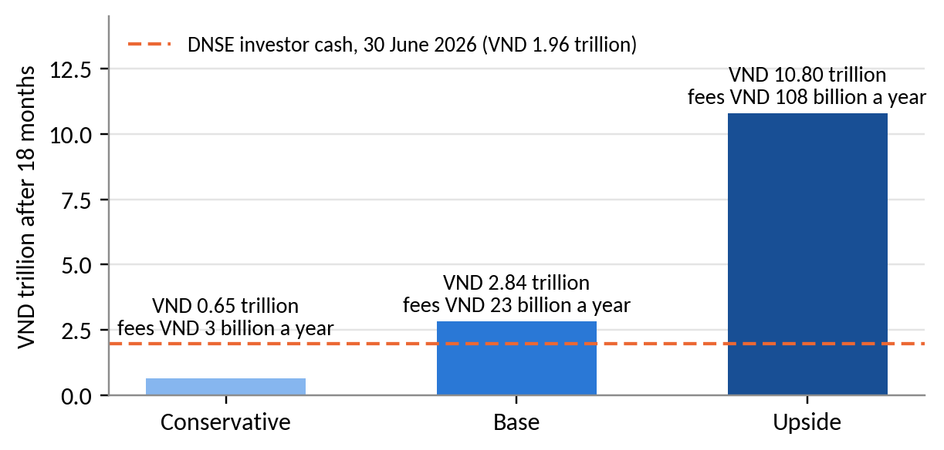
Figure F1. Payday Portfolio assets after 18 months under three scenarios
Source: Table 4.

References
Báo Đấu thầu. (2026, September 3). CPI tháng 8/2026 tăng 0,47% [CPI rose 0.47% in August 2026]. https://baodauthau.vn/cpi-thang-82026-tang-047-post206275.html
CafeF. (2024, November 21). Công ty đứng sau thương vụ IPO duy nhất của thị trường Việt Nam năm 2024 [The company behind Vietnam's only IPO of 2024]. https://cafef.vn/cong-ty-dung-sau-thuong-vu-ipo-duy-nhat-cua-thi-truong-viet-nam-nam-2024-chu-tich-tung-la-ceo-tre-nhat-lich-su-vndirect-loi-nhuan-tang-truong-hon-100-lan-trong-4-nam-188241121113910237.chn
CafeF. (2026, July 22). Soi số lợi nhuận 15.200 tỷ của ngành chứng khoán trong quý 2 [The securities industry's VND 15,200 billion profit in Q2]. https://cafef.vn/soi-so-loi-nhuan-15200-ty-cua-nganh-chung-khoan-trong-quy-2-mot-cuoc-doi-ngoi-dang-am-tham-dien-ra-188260722020054991.chn
DNSE Securities. (2025). So sánh các chương trình "sinh lời tự động" từ tiền nhàn rỗi 2025 [Comparison of automatic-earning programmes for idle cash, 2025]. https://www.dnse.com.vn/hoc/chuong-trinh-sinh-loi-tu-dong
DNSE Securities. (2026a). Financial statements and investor relations releases, 2019 to the second quarter of 2026. https://ir.dnse.com.vn/vi/ctype-finance_report
DNSE Securities. (2026b). Tài khoản Không Ngủ [Idle-cash account, product page]. Retrieved September 24, 2026, from https://www.dnse.com.vn/san-pham/tai-khoan-khong-ngu
DNSE Securities. (2026c). Báo cáo thường niên 2025 [Annual report 2025]. https://cdn.dnse.com.vn/dnse-assets/CBTT/DSE%20-%20BCTN%202025.pdf
FiinRatings. (2026). Banking sector: FY2025 recap and 2026 outlook. https://fiinratings.vn/Data/2026/Report/FiinRatings_Vietnam-Banking-2026-Outlook.pdf
Hanoi Stock Exchange. (2026). Quarterly announcements of the ten securities companies with the largest brokerage market share, Q4 2017 to Q2 2026 [Data set]. Retrieved September 25, 2026, from https://www.hnx.vn
Karlan, D., McConnell, M., Mullainathan, S., & Zinman, J. (2016). Getting to the top of mind: How reminders increase saving. Management Science, 62(12), 3393-3411. https://doi.org/10.1287/mnsc.2015.2296
Kemp, S. (2026). Digital 2026: Vietnam. DataReportal. https://datareportal.com/reports/digital-2026-vietnam
KPMG Vietnam. (2025). Vietnam 2026 outlook. https://assets.kpmg.com/content/dam/kpmgsites/vn/pdf/2025/10/vietnam-2026-outlook.pdf
Madrian, B. C., & Shea, D. F. (2001). The power of suggestion: Inertia in 401(k) participation and savings behavior. The Quarterly Journal of Economics, 116(4), 1149-1187. https://doi.org/10.1162/003355301753265543
Market Times. (2026, August 17). Chứng khoán DNSE (DSE) của Chủ tịch Nguyễn Hoàng Giang bị phạt hơn 800 triệu đồng vì loạt vi phạm trong hoạt động chứng khoán [DNSE fined more than VND 800 million for securities violations]. https://markettimes.vn/chung-khoan-dnse-dse-cua-chu-tich-nguyen-hoang-giang-bi-phat-128642.html
Nhân Dân. (2025, July 8). Công bố khảo sát 2025 về nhu cầu quản lý tài sản và đầu tư của người Việt [2025 survey of Vietnamese wealth management and investment needs]. https://nhandan.vn/cong-bo-khao-sat-2025-ve-nhu-cau-quan-ly-tai-san-va-dau-tu-cua-nguoi-viet-post892406.html
O'Donoghue, T., & Rabin, M. (1999). Doing it now or later. American Economic Review, 89(1), 103-124. https://doi.org/10.1257/aer.89.1.103
Phụ nữ Việt Nam. (2026, August 19). Công ty Chứng khoán DNSE bị buộc dừng cung cấp dịch vụ tài chính [DNSE ordered to stop providing financial services]. https://phunuvietnam.vn/cong-ty-chung-khoan-dnse-bi-buoc-dung-cung-cap-dich-vu-tai-chinh-238260818165854342.htm
State Bank of Vietnam. (2024). Circular No. 64/2024/TT-NHNN on the implementation of open application programming interfaces in the banking sector.
TCBS. (2026). iPower [Product page]. Retrieved September 24, 2026, from https://www.tcbs.com.vn/ca-nhan/san-pham/ipower/
Thaler, R. H., & Benartzi, S. (2004). Save More Tomorrow: Using behavioral economics to increase employee saving. Journal of Political Economy, 112(S1), S164-S187. https://doi.org/10.1086/380085
Thanh Niên. (2023, July 17). ZaloPay hợp tác DNSE để trở thành ví điện tử hỗ trợ đầu tư chứng khoán [ZaloPay partners with DNSE to support securities investment]. https://thanhnien.vn/zalopay-hop-tac-dnse-de-tro-thanh-vi-dien-tu-ho-tro-dau-tu-chung-khoan-185230717103958115.htm
Thanh Niên. (2025, December 31). VN-Index kết thúc năm 2025 với mức tăng khủng gần 41% [The VN-Index ends 2025 up almost 41%]. https://thanhnien.vn/vn-index-ket-thuc-nam-2025-voi-muc-tang-khung-gan-41-185251231154434459.htm
Thương hiệu & Công luận. (2024). Công ty Cổ phần Chứng khoán DNSE bị xử phạt 125 triệu đồng [DNSE fined VND 125 million]. https://thuonghieucongluan.com.vn/cong-ty-co-phan-chung-khoan-dnse-bi-xu-phat-125-trieu-dong-a243582.html
Vietcap Securities. (2026). Financial statements of DSE and other securities companies, Q1 2018 to Q2 2026 [Data set]. Vietcap IQ. Retrieved September 24, 2026, from https://iq.vietcap.com.vn
VietnamNet. (2026, September 9). Lãi suất ngân hàng hôm nay 9/9/2026 [Bank interest rates on 9 September 2026]. https://vietnamnet.vn/lai-suat-ngan-hang-hom-nay-9-9-2026-lai-suat-ngan-hang-big4-len-den-8-nam-2553329.html
Vietstock. (2025, May). Công ty chứng khoán Top 2 thị phần phái sinh "chơi lớn" miễn phí ký quỹ phái sinh [The number-two derivatives broker waives derivatives margin fees]. https://vietstock.vn/2025/05/cong-ty-chung-khoan-top-2-thi-phan-phai-sinh-choi-lon-mien-phi-ky-quy-phai-sinh-4186-1307372.htm
Vietstock. (2026a, March 26). Những nội dung đáng chú ý ở ĐHĐCĐ thường niên DNSE 2026 [Highlights of DNSE's 2026 AGM]. https://vietstock.vn/2026/03/nhung-noi-dung-dang-chu-y-o-dhdcd-thuong-nien-dnse-2026-737-1415846.htm
Vietstock. (2026b, June 2). Sự trỗi dậy của các công ty chứng khoán thuộc ngân hàng [The rise of bank-owned securities companies]. https://vietstock.vn/2026/06/su-troi-day-cua-cac-cong-ty-chung-khoan-thuoc-ngan-hang-757-1449465.htm
Vietstock. (2026c, July 21). Dư nợ margin lập kỷ lục 454 ngàn tỷ đồng, cuộc đua có sự phân hóa [Margin lending reaches a record VND 454 trillion]. https://vietstock.vn/2026/07/du-no-margin-lap-ky-luc-454-ngan-ty-dong-cuoc-dua-co-su-phan-hoa-830-1468883.htm
Vietstock. (2026d, August 4). Mảng cho vay trở thành trụ cột lợi nhuận của ngành chứng khoán [Lending becomes the profit pillar of the securities industry]. https://vietstock.vn/2026/08/mang-cho-vay-tro-thanh-tru-cot-loi-nhuan-cua-nganh-chung-khoan-737-1475738.htm
Vietstock. (2026e, August 13). Tiền gửi cư dân vào ngân hàng lập kỷ lục hơn 11 triệu tỷ [Household bank deposits reach a record above VND 11 quadrillion]. https://vietstock.vn/2026/08/tien-gui-cu-dan-vao-ngan-hang-lap-ky-luc-hon-11-trieu-ty-757-1480068.htm
VnEconomy. (2025, July 8). Lời giải nào cho nghịch lý giữa kỳ vọng sinh lời và tâm lý e ngại của nhà đầu tư Việt? [Resolving the paradox between Vietnamese investors' return expectations and caution]. https://vneconomy.vn/loi-giai-nao-cho-nghich-ly-giua-ky-vong-sinh-loi-va-tam-ly-e-ngai-cua-nha-dau-tu-viet.htm
VnEconomy. (2026, July 22). Lãi suất cao khiến số dư tiền gửi của nhà đầu tư tại công ty chứng khoán giảm về mức thấp nhất 1 năm? [High interest rates push investor deposits at brokers to a one-year low]. https://vneconomy.vn/lai-suat-cao-khien-so-du-tien-gui-cua-nha-dau-tu-tai-cong-ty-chung-khoan-giam-ve-muc-thap-nhat-1-nam.htm
VnExpress. (2025, July 21). Cách DNSE thu hút khách hàng gen Z [How DNSE attracts Gen Z customers]. https://vnexpress.net/cach-dnse-thu-hut-khach-hang-gen-z-4916725.html
VnExpress. (2026a, September 10). Người Việt mở thêm 2 triệu tài khoản chứng khoán sau 8 tháng [Vietnamese open 2 million more securities accounts in eight months]. https://vnexpress.net/nguoi-viet-mo-them-2-trieu-tai-khoan-chung-khoan-sau-8-thang-5118477.html
VnExpress. (2026b, September 23). Thêm nhiều ngân hàng trả lãi tiết kiệm trên 9% [More banks pay savings rates above 9%]. https://vnexpress.net/them-nhieu-ngan-hang-tra-lai-tiet-kiem-tren-9-5123534.html
World Bank. (2025). Global Financial Inclusion (Global Findex) database 2025, Vietnam [Data set]. World Bank Open Data. Retrieved September 20, 2026, from https://api.worldbank.org/v2/sources/28/country/VNM/series/all/data?format=json

